image1.png

Czech eMan reports a record profit and continues to strengthen its position on the market

**Prague, June 28, 2024 - The Prague software house eMan has published its financial results for 2023 and reports another successful year. The company's turnover reached a stable level of almost 255 million crowns and a profit of over 10 million crowns.**

(INSIDE INFORMATION)

Despite a comparable turnover with the previous year, eMan achieved a jump in profit. For the year 2023, it reports a turnover of 254.4 million crowns, which is proof of the company's continued growth. EBITDA operating profit was 25.7 million crowns and the economic result after taxation was 10.4 million crowns.

"*The year 2023 was a key period for restructuring processes and setting the right strategy towards higher performance. The changes in the management of the company proved to be the right move. We were able to reduce operating costs by approximately 24 million crowns. We stagnated in turnover, but we significantly increased EBITDU*," says Jiří Horyna, co-founder and CEO of the company.

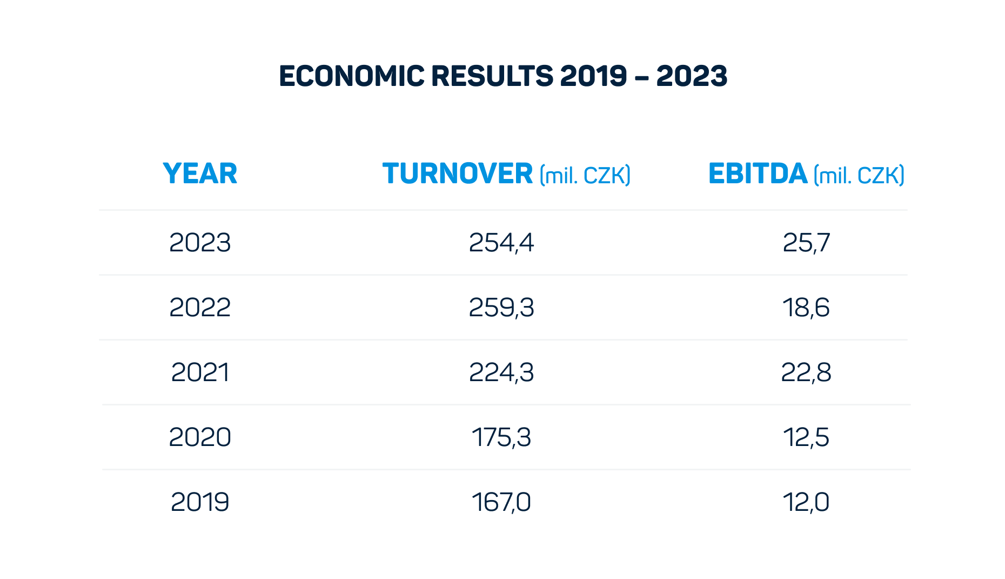

**Changes in management - Jiří Horyna again CEO**

In 2023, significant changes in management and cost restructuring took place, which led to an increase in the overall efficiency and profitability of the company. Jiří Horyna, the chairman of the board of directors, returned to the head of the company, having already served in the position of CEO until 2021. The further acceleration of the use of artificial intelligence (AI) in the implementation of orders and across company processes also contributed to positive results.

**The number of customers is growing. eMan is now working, for example, for Česká spořitelna or the Ministry for Regional Development**

The year 2023 was also a year of significant events for eMan. The company continued to successfully implement long-term projects for important clients such as ČSOB, Volkswagen, CENDIS, E.ON, PPL, Škoda Auto or ABB. There was also the acquisition of new customers, including the Ministry for Regional Development of the Czech Republic, Česká spořitelna, ČSOB Slovensko, Future Life and Energo-Pro.

"*The year 2023 was a period of significant progress and growth for our company. We successfully implemented a number of key projects for our long-term customers and at the same time started cooperation with new partners. Thanks to innovations and strategic changes in management, we managed to increase the efficiency and profitability of the company. We look forward to another successful year 2024, when we will continue to expand our portfolio and start new ambitious projects*," says Horyna.

The company successfully launched the new BrightVibe brand last year and intensively developed the first projects under the eMan Innovations fund, such as Zenplanto and Senfina Labs.

**Ambitious plans for 2024 - higher turnover, strengthening of the American branch and own investments**

For the year 2024, eMan plans to start the implementation of new large-scale projects for new customers, such as the Ministry for Regional Development of the Czech Republic with the National Spatial Planning Geoportal project or the Institute of Health Information and Statistics of the Czech Republic.

The company also launched an IT specialist outsourcing agency under the eMan Alfa brand in the first half of 2024 and will continue to expand the portfolio of the eMan Innovations investment fund and strengthen the American branch in Houston.

eMan expects a turnover of 260 million crowns for 2024. The company is ready to continue growing and strengthening its market position thanks to innovation and quality services for its clients.

**\*\*\***

**About eMan:**

eMan is a leading Czech software supplier. It specializes in mobile and web application development and related services such as UI/UX design, support and service, IT specialist outsourcing and consulting. It mainly focuses on clients from the automotive industry, energy, banking, insurance, industry and services. The quality of the developed solutions is confirmed by dozens of received awards. eMan operates in the Czech Republic and the United States of America. Since 2020, the company's shares have been freely traded on the PX Start market on the Prague Stock Exchange and on the RM-Systém exchange, which is operated by Fio banka.

**Media Contact:**

Nicole Baron

nicole.baronova@abbba.cz

+420 776 204 565

ABBBA Consulting

Renata Faltejsková

renata.faltejskova@abbba.cz

+420 774 888 900

ABBBA Consulting